# V^2 vs. CoreQPower

Definitions from Mark’s :

**Core Q Power**: Calculated Joule heating caused by Q pulse heating in core. The RMS Voltage at the entrance and exit of the core in calculated from data acquired from an oscilloscope with two probes. Measured every 10 seconds. Core Q Power = (V1rms – V2rms) * V2rms / Zeffective Zeffective is calibrated such that the Coefficient of Performance is 1 when the core is running in Helium gas. Compensated for the Q pulse measurement off time to yield average Q pulse joule heating in core- Q pulse in on for 9.4s , off for 0.6s.Verification of this measurement is a work in progress. It correlates linearly with drop in heater power when running at constant temperature.

**Core Q V1 rms** (V1): RMS voltage measured at entrance of the core Q pulse waveguide. Measured by oscilloscope

**Core Q V2 rms** (V2): RMS voltage measured at exit of the core Q pulse waveguide. Measured by oscilloscope

Here is what Core Q Power formular

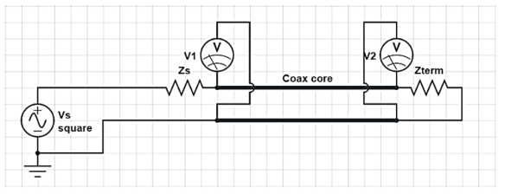

I = V1/(Rcore+Rterm)

P = (V1-V2)*V1/(Rcore+Rterm)

V2 = V1*Rterm/(Rcore + Rterm)

V1 = V2*(Rcore + Rterm) / Rterm

P = (V1-V2)*V2 / Rterm

In DC

Pdc = Vcoredrop * I; only core is being considered.

So in order to get a good comparison: we recommend using

P = (V1-V2)^2/Rcore

Here are two plots with Hpdrop vs. (V1-V2)^2 and HpDrop vs. CoreQPower of sri-ipb2-27b-hydrogen at different temperatures.



